**Nagios**

**Controller Machine**

Nagios Setup

apt-get update

apt-get insall nagios3

make everything default by clicking tab and enter

and need to provide paasword and need to remember it

which nagios3

it provides the path of nagios3

cd /etc/nagios3/conf.d

here in this path we have configuration files of nagios3

ls



here we can configure everything in nagios like what to monitor, here localhost_nagios2.cfg is the main configuration file

vi contacts.cfg

here we can give the email to get notification of nagios monitoring and we can add the members by giving commas

adduser nagiosadmin

need to add user and give the password of nagios and for details press enter to take everything default

apt-get update

apt-get install members

members nagios

it will show members in the group

usermod -aG nagios nagiosadmin

it will add nagiosadmin to the nagios group

**Host Machine**

here in the host system we need to configure NRPE plugin, using this plugin we can monitor it

apt-get update

apt-get install nagios-nrpe-server nagios-plugins -y

it will install the NRPE plugin

vi /etc/nagios/nrpe.cfg

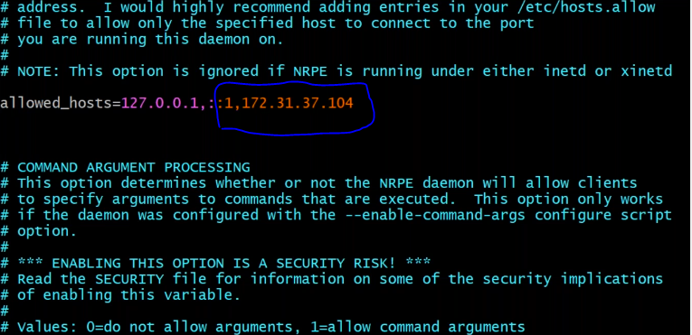

here we should add Controller Machine Private IP address

service nagios-nrpe-server restart

this will restart NRPE plugin

Inbound rules should be allowed to (5666) all traffic

**Controller Machine**

apt-get update

apt-get install nagios-nrpe-plugin

cd /usr/lib/nagios/plugins

chmod 777 check_nrpe

./check_nrpe -H <Host private IP Address>

it will show the version of nrpe version of host i.e., will check whether Host is connected to it or not.

cd /etc/nagios3/conf.d

cp localhost_nagios2.cfg host_nagios2.cfg

it will create a copy with renaming it,

vi host_nagios2.cfg

Before

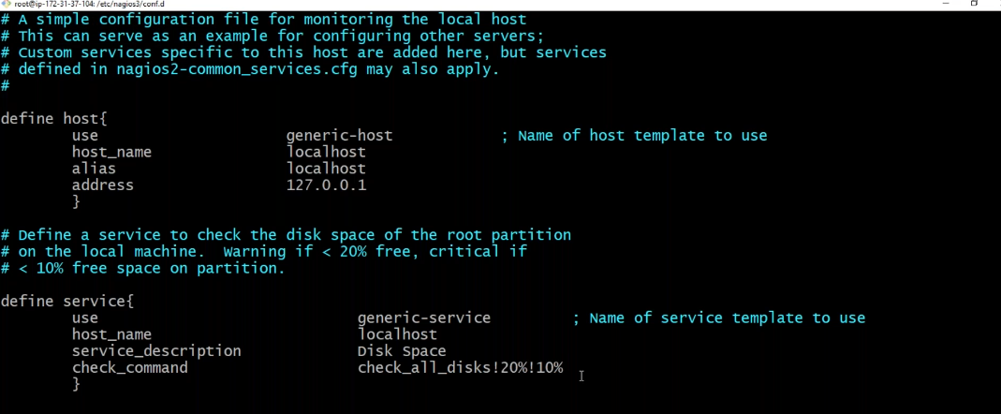

After

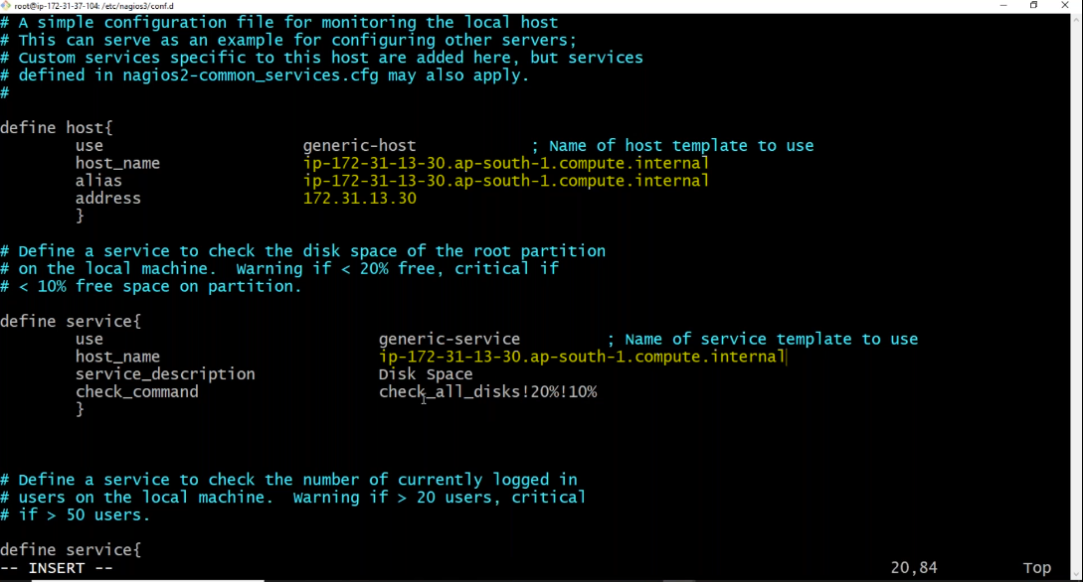

here we will replace the text from local host to of private ipv4 DNS of host machine and Private Ip address of the host machine in all places in this file

lets go to host machine

vi /etc/nagios/nrpe.cfg

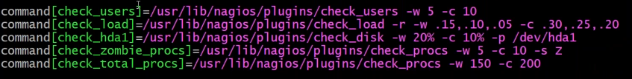

here in bottom we can see this

now again come to controller machine

vi /etc/nagios3/conf.d/ host_nagios2.cfg

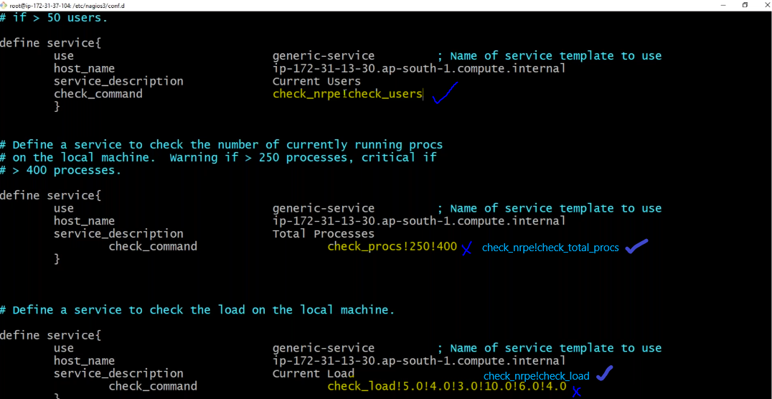

here we need to replace every checkcommand with check_nrpe!<specific command>which we have taken a pic from host machine in the box

service nagios3 restart

then go to browser and enter <ipaddress>/nagios3

give username as nagiosadmin and specific password